***ECS793P - Introduction to Object Oriented Programming 19/20***

***Coursework Report***

***(Computer Store)***

***Sinnadurai Mahendran Pravin Durai (190783415)***

***Introduction***

For this coursework we use C++ to implement a computer store. The computer store has various types of computers such as Desktop, Laptops and Servers. Each having their own specification.  
For storing the data files were used instead of database.

We have used Linked List for storing and retrieving the information from the file. We have customized the data part of the Linked list so that it can store objects of Desktop, Laptop, Server.

***Class Hierarchy***

**MULTIPLE inheritance** - We have a Class called “Computer” inherited from the class called Cpu, Gpu and Memory  
**MULTILEVEL inheritance** – The Classes “Desktop, Laptop and Server” are inherited from “Computer” and ”Computer” is inherited from “Cpu,Gpu,Memory”

The combination of these two makes the Hybrid Inheritance

**HYBRID INHERITANCE**

**Memory**

**Cpu**

**Gpu**

**MULTIPLE INHERITANCE**

Importing header files of  
 Desktop, Laptop and Server into LinkedList class

Importing header file of  
 Linked List to File Operations class

Importing header file of  
 File Operations into MyUi class

**LinkedList**

**FileOperations**

**MyUi**

**COMPUTER**

COMPUTER

COMPUTER

**Desktop**

**Laptop**

**Server**

**MULTILEVEL INHERITANCE**

InputFile.cfg

**~~Database~~/File**

***Function Explanation***

The below table shows some of the important function that i have created for each class, where the actual processing takes place.

The detailed information about all the function is available in the Excel file “Test Case for Computer Store”under the tab “FunctionExplanation”. You can find this file as a part of the project zip file.

|  |  |  |  |
| --- | --- | --- | --- |
| **#Sno** | **Class** | **Function** | **Explanation** |
| 1 | MyUi | create GUI1 | Creates the First screen that shows the List of  Computers (Desktop, Laptop, Server) |
| 2 | createGUI2 | It displays the list of operation that can be performed by the user  for a given computer **NOTE:** Functionality are different for different type of Computers |
| 3 | generateId | This method is used to automatically generate the System ID,  And it's always Unique |
| 4 | FileOperations | listToFile | This is one of the important function for the effecrtive functioning  of the Application. It stores the data from the List to the File before it exist the application |
| 5 | fileToList | This method reads the contents of the file and stores them in the List before any other function gets executed. Post this all the computations are done only in List. |
| 6 | getMaxSysId | This Method is used to find the Maximum value of the system ID that is present in the system. |
| 7 | addNewNode | This method is used to add new Node to the existing Linked List |
| 8 | displayAllNodes | Although the method name says 'displayAllNodes', This method  display only the nodes that are belonging to a particular system |
| 9 | displayCDescription | Used to display the detailed bill for the product along with their  Specifications |
| 10 | Desktop | getAllInputs | This function get the Input from the user and stores them in the object |
| 11 | displayDesktopInputs | Display the inputs received from a particular object to the screen |
| 12 | desktopCostDescription | This fnunction display the destop cost and it's specification to the ouput screen |
| 13 | calculateDesktopCost | It calculate the cost for the Desktop, But in actual it make a call to  the function that is available in super class to calculate the cost. |
| 14 | Laptop | getAllInputs | This function get the Input from the user a nd stores them in the object |
| 15 | displayLaptopInputs | Display the inputs received from a particular  object to the screen |
| 16 | LaptopCostDescription | This fnunction display the destop cost and  it's specification to the ouput screen |
| 17 | calculateLaptopCost | It calculate the cost for the Laptop, But in actual it make a call to  the function that is available in super class to calculate the cost. |
| 18 | Server | getAllInputs | This function get the Input from the user and  stores them in the object |
| 19 | displayServerInputs | Display the inputs received from a particular  object to the screen |
| 20 | ServerCostDescription | This fnunction display the destop cost and it's  specification to the ouput screen |
| 21 | calculateServerCost | It calculate the cost for the Server, But in actual it make a call to  the function that is available in super class to calculate the cost. |
| 22 | Computer | displayCompInputs | This function displays all the inputs that below to Computer class (Eg : CPU, GPU and Memory related info) |
| 23 | displayCompCostInputs | This function Display the Computer  Specification along with its cost |
| 24 | costCalculator | This is were the actual cost is calculated no matter what type of  Computer it is. (Desktop, Laptop, Server) |
| 25 | validateStringInput | This function validates whether the given Input is a integer or a  String |

***Test***

The Application Under Test was tested with various inputs to see if there is any functionality that is not working as expected. The attached Excel sheet contains both positive and negative test cases (The negative test cases are highlighted in Red colour) that are covered during the testing process.

This Excel file is also available in the Zip file.



***Sample Outputs from the Application***

***GUI 1***

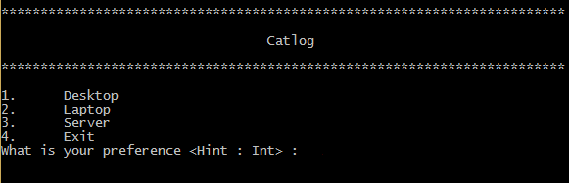

***GUI 2***

***Test Case 2.1***

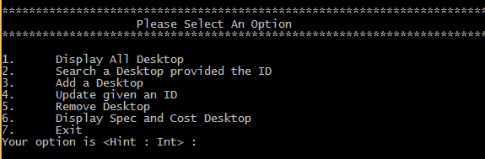

***Test Case 2.1.2***

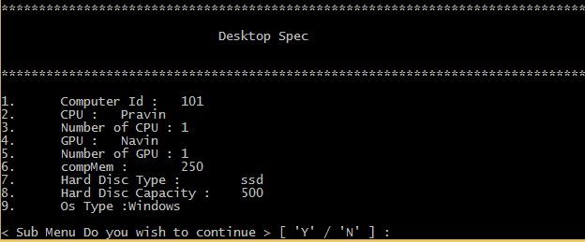

***Test Case 2.2***

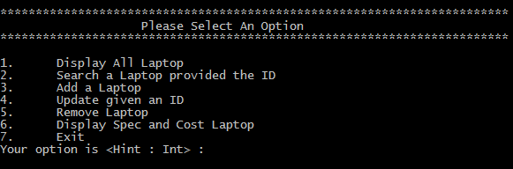

***Test Case 2.3***

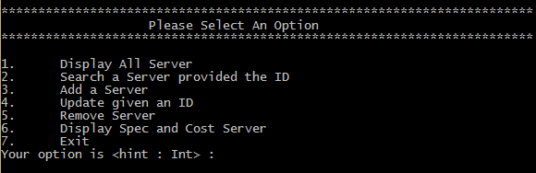

**6. Limitations**

Constraint on user input

The function interface is designed as simple as possible there are certain scenario where the user will be prompted to choose between **‘Y’ or ‘N’**, In this case if the user inputs a character then the application works as expected. But if the users enters a string or an Integer the system prints the same line asking for the inputs based on the length of the string given as input by the user. But the system will not crash.

*Programming Environment: Windows*

*Compiler used: realgcc.exe (Rev1, Built by MSYS2 project) 7.2.0*

*Way to compile the code in console: >>* *g++ Main.cpp MyUi.cpp LinkedList.cpp FileOperations.cpp Desktop.cpp Laptop.cpp Server.cpp Computer.cpp Cpu.cpp Gpu.cpp Memory.cpp -o Main*

*To run the program: >>Main*

***Note:*** *It’s good if you can try in window, Coz, i get some compilation errors when i tried compiling the code in Linux environment .Also certain methods used for clearing the console might be restricted to windows functionality.*

*The code works perfectly fine in windows.*